**ANNEX I**

**SUMMARY OF PRODUCT CHARACTERISTICS**

This medicinal product is subject to additional monitoring. This will allow quick identification of new safety information. Healthcare professionals are asked to report any suspected adverse reactions. See section 4.8 for how to report adverse reactions.

**1. NAME OF THE MEDICINAL PRODUCT**

COVID-19 Vaccine Moderna dispersion for injection

COVID-19 mRNA Vaccine (nucleoside modified)

**2. QUALITATIVE AND QUANTITATIVE COMPOSITION**

This is a multidose vial which contains 10 doses of 0.5 mL.

One dose (0.5 mL) contains 100 micrograms of messenger RNA (mRNA) (embedded in SM-102 lipid nanoparticles).

Single-stranded, 5’-capped messenger RNA (mRNA) produced using a cell-free *in vitro* transcription from the corresponding DNA templates, encoding the viral spike (S) protein of SARS-CoV-2.

For the full list of excipients, see section 6.1.

**3. PHARMACEUTICAL FORM**

Dispersion for injection

White to off white dispersion (pH: 7.0 – 8.0).

**4. CLINICAL PARTICULARS**

**4.1 Therapeutic indications**

COVID-19 Vaccine Moderna is indicated for active immunisation to prevent COVID-19 caused by SARS-CoV-2 in individuals 18 years of age and older.

The use of this vaccine should be in accordance with official recommendations.

**4.2 Posology and method of administration**

Posology

*Individuals 18 years of age and older*

COVID-19 Vaccine Moderna is administered as a course of 2 doses (0.5 mL each). It is recommended to administer the second dose 28 days after the first dose (see sections 4.4 and 5.1).

There are no data available on the interchangeability of COVID-19 Vaccine Moderna with other COVID-19 vaccines to complete the vaccination course. Individuals who have received the first dose of COVID-19 Vaccine Moderna should receive the second dose of COVID-19 Vaccine Moderna to complete the vaccination course.

*Paediatric population*

The safety and efficacy of COVID-19 Vaccine Moderna in children and adolescents less than 18 years of age have not yet been established. No data are available.

*Elderly population*

No dosage adjustment is required in elderly individuals ≥65 years of age.

Method of administration

The vaccine should be administered intramuscularly. The preferred site is the deltoid muscle of the upper arm.

Do not administer this vaccine intravascularly, subcutaneously or intradermally.

The vaccine should not be mixed in the same syringe with any other vaccines or medicinal products.

For precautions to be taken before administering the vaccine, see section 4.4.

For instructions regarding thawing, handling and disposal of the vaccine, see section 6.6.

**4.3 Contraindications**

Hypersensitivity to the active substance or to any of the excipients listed in section 6.1.

**4.4 Special warnings and precautions for use**

Traceability

In order to improve the traceability of biological medicinal products, the name and the batch number of the administered product should be clearly recorded.

Hypersensitivity and anaphylaxis

Anaphylaxis has been reported. Appropriate medical treatment and supervision should always be readily available in case of an anaphylactic reaction following administration of the vaccine.

Close observation for at least 15 minutes is recommended following vaccination. The second dose of the vaccine should not be given to those who have experienced anaphylaxis to the first dose of COVID-19 Vaccine Moderna.

Anxiety-related reactions

Anxiety-related reactions, including vasovagal reactions (syncope), hyperventilation or stress‐related reactions may occur in association with vaccination as a psychogenic response to the needle injection. It is important that precautions are in place to avoid injury from fainting.

Concurrent illness

Vaccination should be postponed in individuals suffering from acute severe febrile illness or acute infection. The presence of a minor infection and/or low-grade fever should not delay vaccination.

Thrombocytopenia and coagulation disorders

As with other intramuscular injections, the vaccine should be given with caution in individuals receiving anticoagulant therapy or those with thrombocytopenia or any coagulation disorder (such as haemophilia) because bleeding or bruising may occur following an intramuscular administration in these individuals.

Immunocompromised individuals

The efficacy, safety and immunogenicity of the vaccine has not been assessed in immunocompromised individuals, including those receiving immunosuppressant therapy. The efficacy of COVID-19 Vaccine Moderna may be lower in immunosuppressed individuals.

Duration of protection

The duration of protection afforded by the vaccine is unknown as it is still being determined by ongoing clinical trials.

Limitations of vaccine effectiveness

Individuals may not be fully protected until 14 days after their second dose. As with all vaccines, vaccination with COVID-19 Vaccine Moderna may not protect all vaccine recipients.

Excipients with known effect

*Sodium*

This vaccine contains less than 1 mmol sodium (23 mg) per 0.5 mL dose, that is to say, essentially ‘sodium-free’.

**4.5 Interaction with other medicinal products and other forms of interaction**

No interaction studies have been performed.

Concomitant administration of COVID-19 Vaccine Moderna with other vaccines has not been studied.

**4.6 Fertility, pregnancy and lactation**

Pregnancy

There is limited experience with use of COVID-19 Vaccine Moderna in pregnant women. Animal studies do not indicate direct or indirect harmful effects with respect to pregnancy, embryo/foetal development, parturition or post-natal development (see section 5.3). Administration of COVID-19 Vaccine Moderna in pregnancy should only be considered when the potential benefits outweigh any potential risks for the mother and foetus.

Breast-feeding

It is unknown whether COVID-19 Vaccine Moderna is excreted in human milk.

Fertility

Animal studies do not indicate direct or indirect harmful effects with respect to reproductive toxicity (see section 5.3).

**4.7 Effects on ability to drive and use machines**

COVID-19 Vaccine Moderna has no or negligible influence on the ability to drive and use machines. However, some of the effects mentioned under section 4.8 may temporarily affect the ability to drive or use machines.

**4.8 Undesirable effects**

Summary of the safety profile

The safety of COVID-19 Vaccine Moderna was evaluated in an ongoing Phase 3 randomised, placebo-controlled, observer-blind clinical trial conducted in the United States involving 30,351 participants 18 years of age and older who received at least one dose of COVID-19 Vaccine Moderna (n=15,185) or placebo (n=15,166) (NCT04470427). At the time of vaccination, the mean age of the population was 52 years (range 18-95); 22,831 (75.2%) of participants were 18 to 64 years of age and 7,520 (24.8%) of participants were 65 years of age and older.

The most frequently reported adverse reactions were pain at the injection site (92%), fatigue (70%), headache (64.7%), myalgia (61.5%), arthralgia (46.4%), chills (45.4%), nausea/vomiting (23%), axillary swelling/tenderness (19.8%), fever (15.5%), injection site swelling (14.7%) and redness (10%). Adverse reactions were usually mild or moderate in intensity and resolved within a few days after vaccination. A slightly lower frequency of reactogenicity events was associated with greater age.

Overall, there was a higher incidence of some adverse reactions in younger age groups: the incidence of axillary swelling/tenderness, fatigue, headache, myalgia, arthralgia, chills, nausea/vomiting and fever was higher in adults aged 18 to < 65 years than in those aged 65 years and above.

Local and systemic adverse reactions were more frequently reported after Dose 2 than after Dose 1.

Tabulated list of adverse reactions

The safety profile presented below is based on data generated in a placebo- controlled clinical study on 30,351 adults ≥ 18 years of age.

Adverse reactions reported are listed according to the following frequency convention:

Very common (≥1/10)

Common (≥1/100 to <1/10)

Uncommon (≥1/1,000 to <1/100)

Rare (≥1/10,000 to <1/1,000)

Very rare (<1/10,000)

Not known (cannot be estimated from the available data)

Within each frequency grouping, adverse reactions are presented in order of decreasing seriousness.

|  |  |  |
| --- | --- | --- |
| **MedDRA System Organ Class** | **Frequency** | **Adverse reactions** |
| **Blood and lymphatic system disorders** | Very common | Lymphadenopathy* |
| **Immune system disorders** | Not known | Anaphylaxis  Hypersensitivity |
| **Nervous system disorders** | Very common | Headache |
| Rare | Acute peripheral facial paralysis** |
| **Gastrointestinal disorders** | Very common | Nausea/vomiting |
| **Skin and subcutaneous tissue disorders** | Common | Rash |
| **Musculoskeletal and connective tissue disorders** | Very common | Myalgia  Arthralgia |
| **General disorders and administration site conditions** | Very common | Injection site pain  Fatigue  Chills  Pyrexia  Injection site swelling |
| Common | Injection site erythema, Injection site urticaria, Injection site rash |
| Uncommon | Injection site pruritus |
| Rare | Facial swelling*** |

*Lymphadenopathy was captured as axillary lymphadenopathy on the same side as the injection site.

**Throughout the safety follow-up period, acute peripheral facial paralysis (or palsy) was reported by three participants in the COVID-19 Vaccine Moderna group and one participant in the placebo group. Onset in the vaccine group participants was 22 days, 28 days, and 32 days after Dose 2.

***There were two serious adverse events of facial swelling in vaccine recipients with a history of injection of dermatological fillers. The onset of swelling was reported 1 and 2 days, respectively, after vaccination

The reactogenicity and safety profile in 343 subjects receiving COVID-19 Vaccine Moderna, that were seropositive for SARS-CoV-2 at baseline, was comparable to that in subjects seronegative for SARS-CoV-2 at baseline.

Reporting of suspected adverse reactions

Reporting suspected adverse reactions after authorisation of the medicinal product is important. It allows continued monitoring of the benefit/risk balance of the medicinal product. Healthcare professionals are asked to report any suspected adverse reactions via the national reporting system listed in [Appendix V](http://www.ema.europa.eu/docs/en_GB/document_library/Template_or_form/2013/03/WC500139752.doc) and include batch/Lot number if available.

**4.9 Overdose**

No case of overdose has been reported.

In the event of overdose, monitoring of vital functions and possible symptomatic treatment is recommended.

**5. PHARMACOLOGICAL PROPERTIES**

**5.1 Pharmacodynamic properties**

Pharmacotherapeutic group: Vaccine, other viral vaccines, ATC code: J07BX03

Mechanism of action

COVID-19 Vaccine Moderna contains mRNA encapsulated in lipid nanoparticles. The mRNA encodes for the full-length SARS-CoV-2 spike protein modified with 2 proline substitutions within the heptad repeat 1 domain (S-2P) to stabilise the spike protein into a prefusion conformation. After intramuscular injection, cells at the injection site and the draining lymph nodes take up the lipid nanoparticle, effectively delivering the mRNA sequence into cells for translation into viral protein. The delivered mRNA does not enter the cellular nucleus or interact with the genome, is non-replicating, and is expressed transiently mainly by dendritic cells and subcapsular sinus macrophages. The expressed, membrane-bound spike protein of SARS-CoV-2 is then recognised by immune cells as a foreign antigen. This elicits both T-cell and B-cell responses to generate neutralising antibodies, which may contribute to protection against COVID-19.

Clinical efficacy

The randomised, placebo-controlled, observer-blind Phase 3 clinical study (NCT04470427) excluded individuals who were immunocompromised or had received immunosuppressants within 6 months, as well as participants who were pregnant, or with a known history of SARS-CoV-2 infection. Participants with stable HIV disease were not excluded. Influenza vaccines could be administered 14 days before or 14 days after any dose of COVID-19 Vaccine Moderna. Participants were also required to observe a minimum interval of 3 months after receipt of blood/plasma products or immunoglobulins prior to the study in order to receive either placebo or COVID-19 Vaccine Moderna.

A total of 30,351 subjects were followed for a median of 92 days (range: 1-122) for the development of COVID-19 disease.

The primary efficacy analysis population (referred to as the Per Protocol Set or PPS), included 28,207 subjects who received either COVID-19 Vaccine Moderna (n=14,134) or placebo (n=14,073) and had a negative baseline SARS-CoV-2 status. The PPS study population included 47.4% female, 52.6% male, 79.5% White, 9.7% African American, 4.6% Asian, and 6.2% other. 19.7% of participants identified as Hispanic or Latino. The median age of subjects was 53 years (range 18-94). A dosing window of –7 to +14 days for administration of the second dose (scheduled at day 29) was allowed for inclusion in the PPS. 98% of vaccine recipients received the second dose 25 days to 35 days after dose 1 (corresponding to -3 to +7 days around the interval of 28 days).

COVID-19 cases were confirmed by Reverse Transcriptase Polymerase Chain Reaction (RT PCR) and by a Clinical Adjudication Committee. Vaccine efficacy overall and by key age groups are presented in Table 2.

**Table 2: Vaccine Efficacy Analysis: confirmed COVID-19# regardless of severity starting 14 days after the 2nd dose – Per-Protocol Set**

|  |  |  |  |  |  |  |  |
| --- | --- | --- | --- | --- | --- | --- | --- |
| **Age Group (Years)** | **COVID-19 Vaccine Moderna** | | | **Placebo** | | |  |
| **Subjects**  **N** | **COVID-19 Cases**  **n** | **Incidence Rate**  **of COVID-19 per 1,000 Person-Years** | **Subjects**  **N** | **COVID-19 Cases**  **n** | **Incidence Rate of COVID-19 per 1,000 Person-Years** | **% Vaccine Efficacy (95% CI)\*** |
| Overall  (≥18) | 14,134 | 11 | 3.328 | 14,073 | 185 | 56.510 | 94.1  (89.3, 96.8)** |
| 18 to <65 | 10,551 | 7 | 2.875 | 10,521 | 156 | 64.625 | 95.6  (90.6, 97.9) |
| ≥65 | 3,583 | 4 | 4.595 | 3,552 | 29 | 33.728 | 86.4  (61.4, 95.2) |
| ≥65 to <75 | 2,953 | 4 | 5.586 | 2,864 | 22 | 31.744 | 82.4%  (48.9, 93.9) |
| ≥75 | 630 | 0 | 0 | 688 | 7 | 41.968 | 100%  (NE, 100) |

#COVID-19: symptomatic COVID-19 requiring positive RT-PCR result and at least 2 systemic symptoms or 1 respiratory symptom. Cases starting 14 days after the 2nd dose.

*Vaccine efficacy and 95% confidence interval (CI) from the stratified Cox proportional hazard model

** CI not adjusted for multiplicity. Multiplicity adjusted statistical analyses were carried out in an interim analysis based on less COVID-19 cases, not reported here.

Among all subjects in the PPS, no cases of severe COVID-19 were reported in the vaccine group compared with 30 of 185 (16%) cases reported in the placebo group. Of the 30 participants with severe disease, 9 were hospitalised, 2 of which were admitted to an intensive care unit. The majority of the remaining severe cases fulfilled only the oxygen saturation (SpO2) criterion for severe disease (≤ 93% on room air).

The vaccine efficacy of COVID-19 Vaccine Moderna to prevent COVID-19, regardless of prior SARS-CoV-2 infection (determined by baseline serology and nasopharyngeal swab sample testing) from 14 days after Dose 2 was 93.6% (95% confidence interval 88.5, 96.4%).

Additionally, subgroup analyses of the primary efficacy endpoint showed similar efficacy point estimates across genders, ethnic groups, and participants with medical comorbidities associated with high risk of severe COVID-19.

Elderly population

COVID-19 Vaccine Moderna was assessed in individuals 18 years of age and older, including 3,768 subjects 65 years of age and older. The efficacy of COVID-19 Vaccine Moderna was consistent between elderly (≥65 years) and younger adult subjects (18-64 years).

Paediatric population

The European Medicines Agency has deferred the obligation to submit the results of studies with the COVID-19 Vaccine Moderna in one or more subsets of the paediatric population in prevention of COVID-19 (see section 4.2 for information on paediatric use).

Conditional Approval

This medicinal product has been authorised under a so-called ‘conditional approval’ scheme. This means that further evidence on this medicinal product is awaited. The European Medicines Agency will review new information on this medicinal product at least every year and this SmPC will be updated as necessary.

**5.2 Pharmacokinetic properties**

Not applicable.

**5.3 Preclinical safety data**

Non-clinical data reveal no special hazard for humans based on conventional studies of repeat dose toxicity and reproductive and developmental toxicity.

General Toxicity:

General toxicity studies were conducted in rats (intramuscularly receiving up to 4 doses exceeding the human dose once every 2 weeks). Transient and reversible injection site oedema and erythema and transient and reversible changes in laboratory tests (including increases in eosinophils, activated partial thromboplastin time, and fibrinogen) were observed. Results suggests the toxicity potential to humans is low.

Genotoxicity/Carcinogenicity:

In vitro and in vivo genotoxicity studies were conducted with the novel lipid component SM-102 of the vaccine. Results suggests the genotoxicity potential to humans is very low. Carcinogenicity studies were not performed.

Reproductive Toxicity:

In a developmental toxicity study, 0.2 mL of a vaccine formulation containing the same quantity of mRNA (100 micrograms) and other ingredients included in a single human dose of COVID-19 Vaccine Moderna was administered to female rats by the intramuscular route on four occasions: 28 and 14 days prior to mating, and on gestation days 1 and 13. SARS-CoV-2 antibody responses were present in maternal animals from prior to mating to the end of the study on lactation day 21 as well as in foetuses and offspring. There were no vaccine-related adverse effects on female fertility, pregnancy, embryo foetal or offspring development or postnatal development. No data are available of mRNA-1273 vaccine placental transfer or excretion in milk.

**6. PHARMACEUTICAL PARTICULARS**

**6.1 List of excipients**

Lipid SM-102

Cholesterol

1,2-distearoyl-sn-glycero-3-phosphocholine (DSPC)

1,2-Dimyristoyl-rac-glycero-3-methoxypolyethylene glycol-2000 (PEG2000 DMG)

Tromethamol

Tromethamol hydrochloride

Acetic acid

Sodium acetate trihydrate

Sucrose

Water for injections

**6.2 Incompatibilities**

This medicinal product must not be mixed with other medicinal products or diluted.

**6.3 Shelf life**

Unopened vial:

7 months at -25ºC to -15ºC.

The unopened vaccine may be stored refrigerated at 2°C to 8°C, protected from light, for maximum 30 days.

Once thawed the vaccine should not be re-frozen.

The unopened vaccine may be stored at 8°C to 25°C up to 12 hours after removal from refrigerated conditions.

Punctured Vial:

Chemical and physical in-use stability has been demonstrated for 6 hours at 2°C to 25ºC after initial puncture. From a microbiological point of view, the product should be used immediately. If the vaccine is not used immediately, in-use storage times and conditions are the responsibility of the user

**6.4 Special precautions for storage**

Store in a freezer frozen between -25ºC to -15ºC.

Store in the original carton to protect from light.

Do not store on dry ice or below -40ºC.

For storage conditions after thawing and first opening see section 6.3.

**6.5 Nature and contents of container**

5 ml dispersion in a vial (type 1 or type 1 equivalent glass) with a stopper (chlorobutyl rubber) and a flip-off plastic cap with seal (aluminium seal).

Each vial contains 10 doses of 0.5mL.

Pack size: 10 multidose vials

**6.6 Special precautions for disposal and other handling**

The vaccine should be prepared and administered by a trained healthcare professional using aseptic techniques to ensure sterility of the dispersion.

The vaccine comes ready to use once thawed.

Do not shake or dilute. Swirl the vial gently after thawing and before each withdrawal.

COVID-19 Vaccine Moderna vials are multidose.

Ten (10) doses (of 0.5mL each) can be withdrawn from each vial.

An additional overfill is included in each vial to ensure that 10 doses of 0.5 mL can be delivered.

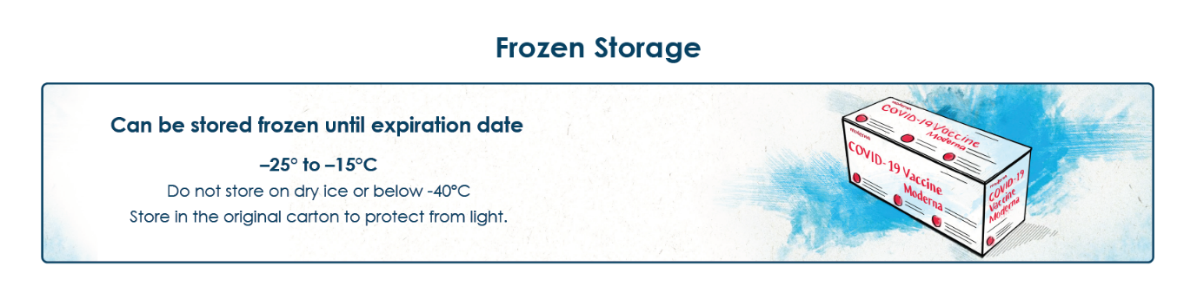

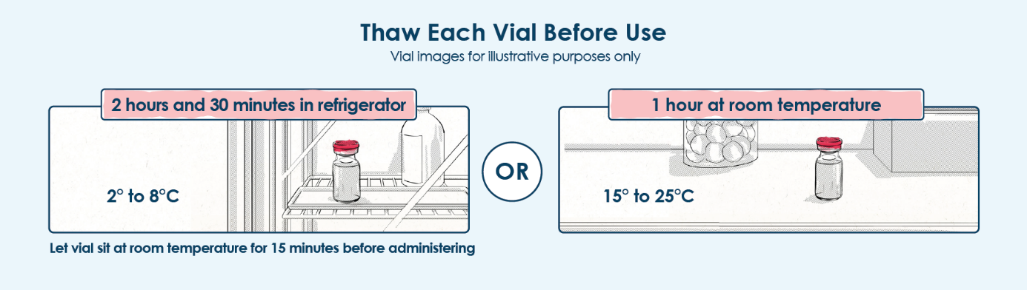

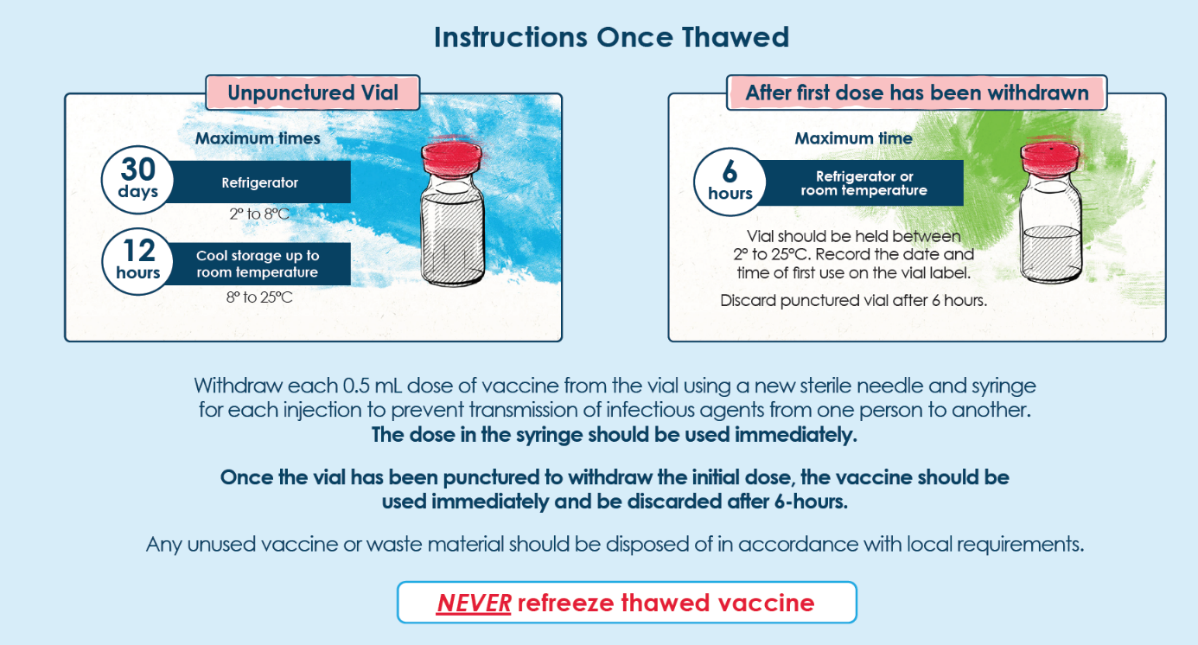

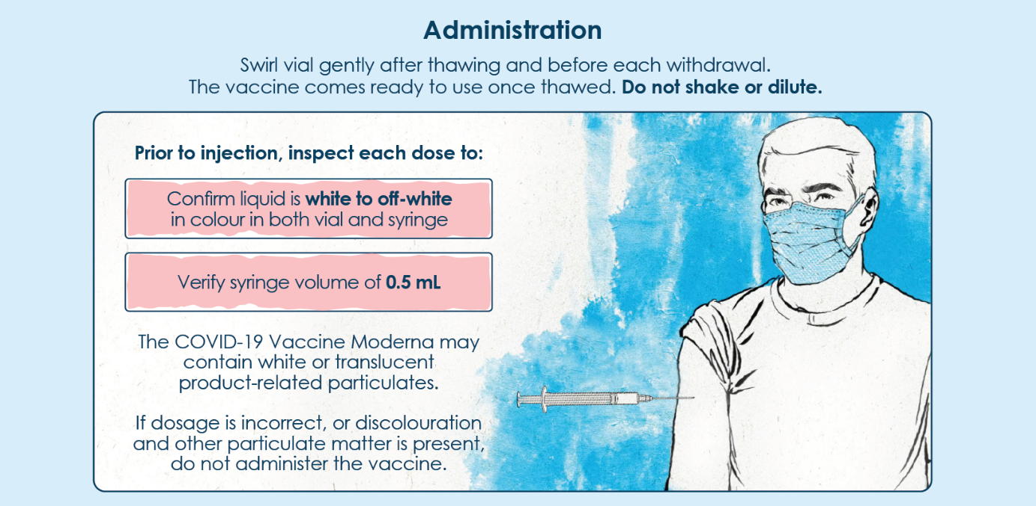

**7. MARKETING AUTHORISATION HOLDER**

MODERNA BIOTECH SPAIN, S.L.

Calle Monte Esquinza 30

28010 Madrid

Spain

**8. MARKETING AUTHORISATION NUMBER(S)**

EU/1/20/1507/001

**9. DATE OF FIRST AUTHORISATION/RENEWAL OF THE AUTHORISATION**

Date of first authorisation: {DD month YYYY}

**10. DATE OF REVISION OF THE TEXT**

Detailed information on this medicinal product is available on the website of the European Medicines Agency <http://www.ema.europa.eu>.

**ANNEX II**

**A. MANUFACTURER OF THE BIOLOGICAL ACTIVE SUBSTANCE AND MANUFACTURER RESPONSIBLE FOR BATCH RELEASE**

**B. CONDITIONS OR RESTRICTIONS REGARDING SUPPLY AND USE**

**C. OTHER CONDITIONS AND REQUIREMENTS OF THE MARKETING AUTHORISATION**

**D. conditions or restrictions with regard to the safe and effective use of the medicinal product**

**E. SPECIFIC OBLIGATION TO COMPLETE POST-AUTHORISATION MEASURES FOR THE CONDITIONAL MARKETING AUTHORISATION**

**A.** **MANUFACTURER OF THE BIOLOGICAL ACTIVE SUBSTANCE AND MANUFACTURER RESPONSIBLE FOR BATCH RELEASE**

Name and address of the manufacturer of the biological active substance

LONZA AG

Lonzastrasse 2

Visp 3930

Switzerland

Name and address of the manufacturer responsible for batch release

Rovi Pharma Industrial Services, S.A.

Paseo de Europa, 50

28703. San Sebastián de los Reyes

Madrid, Spain

In view of the declared Public Health Emergency of International Concern and in order to ensure early supply this medicinal product is subject to a time-limited exemption allowing reliance on batch control testing conducted in the registered site(s) that are located in a third country. This exemption ceases to be valid on 31 January 2021. Implementation of EU based batch control arrangements, including the necessary variations to the terms of the marketing authorisation, has to be completed by 31 January 2021 at the latest, in line with the agreed plan for this transfer of testing.

**B.** **CONDITIONS OR RESTRICTIONS REGARDING SUPPLY AND USE**

Medicinal product subject to medical prescription.

**Official batch release**

In accordance with Article 114 of Directive 2001/83/EC, the official batch release will be undertaken by a state laboratory or a laboratory designated for that purpose.

**C. OTHER CONDITIONS AND REQUIREMENTS OF THE MARKETING AUTHORISATION**

**Periodic safety update reports (PSURs)**

The requirements for submission of PSURs for this medicinal product are set out in the list of Union reference dates (EURD list) provided for under Article 107c(7) of Directive 2001/83/EC and any subsequent updates published on the European medicines web-portal.

The marketing authorisation holder (MAH) shall submit the first PSUR for this product within 6 months following authorisation.

**D. CONDITIONS OR RESTRICTIONS WITH REGARD TO THE SAFE AND EFFECTIVE USE OF THE MEDICINAL PRODUCT**

**Risk management plan (RMP)**

The marketing authorisation holder (MAH) shall perform the required pharmacovigilance activities and interventions detailed in the agreed RMP presented in Module 1.8.2 of the marketing authorisation and any agreed subsequent updates of the RMP.

An updated RMP should be submitted:

* At the request of the European Medicines Agency;
* Whenever the risk management system is modified, especially as the result of new information being received that may lead to a significant change to the benefit/risk profile or as the result of an important (pharmacovigilance or risk minimisation) milestone being reached.

**E. SPECIFIC OBLIGATION TO COMPLETE POST-AUTHORISATION MEASURES FOR THE CONDITIONAL MARKETING AUTHORISATION**

This being a conditional marketing authorisation and pursuant to Article 14-a of Regulation (EC) No 726/2004, the MAH shall complete, within the stated timeframe, the following measures:

| **Description** | **Due date** |
| --- | --- |
| In order to complete the characterisation of the active substance and finished product manufacturing processes, the MAH should provide additional data. | January 2021 |
| In order to confirm the consistency of the active substance and finished product manufacturing process (Initial and final scales), the MAH should provide additional comparability and validation data. | April 2021  Interim reports will be provided monthly prior to this date. |
| In order to ensure consistent product quality, the MAH should provide additional information on stability of the active substance and finished product and review the active substance and finished product specifications following further manufacturing experience. | June 2021 |
| In order to confirm the efficacy and safety of COVID-19 Vaccine Moderna, the MAH should submit the final Clinical Study Report for the randomised, placebo-controlled, observer-blind study mRNA-1273-P301. | December 2022 |

**ANNEX III**

**LABELLING AND PACKAGE LEAFLET**

**A. LABELLING**

**PARTICULARS TO APPEAR ON THE OUTER PACKAGING**

**OUTER CARTON**

**1. NAME OF THE MEDICINAL PRODUCT**

COVID-19 Vaccine Moderna dispersion for injection

COVID-19 mRNA Vaccine (nucleoside modified)

**2. STATEMENT OF ACTIVE SUBSTANCE(S)**

Each multidose vial contains 10 doses (0.5 mL each).

**3. LIST OF EXCIPIENTS**

Excipients: Lipid SM-102, cholesterol, 1,2-distearoyl-sn-glycero-3-phosphocholine (DSPC), 1,2-Dimyristoyl-rac-glycero-3-methoxypolyethylene glycol-2000 (PEG2000 DMG), tromethamol, tromethamol hydrochloride, acetic acid, sodium acetate trihydrate, sucrose, water for injections.

**4. PHARMACEUTICAL FORM AND CONTENTS**

Dispersion for injection

10 multidose vials

**5. METHOD AND ROUTE(S) OF ADMINISTRATION**

Intramuscular use.

Read the package leaflet before use.



Scan here for package leaflet or visit [www.modernacovid19global.com](http://www.modernacovid19global.com).

**6. SPECIAL WARNING THAT THE MEDICINAL PRODUCT MUST BE STORED OUT OF THE SIGHT AND REACH OF CHILDREN**

Keep out of sight and reach of children.

**7. OTHER SPECIAL WARNING(S), IF NECESSARY**

**8. EXPIRY DATE**

EXP

**9. SPECIAL STORAGE CONDITIONS**

Store frozen at -25°C to -15°C.

Read the package leaflet for the shelf life after first opening and for additional storage information.

Keep the vial in the outer carton to protect from light

**10. SPECIAL PRECAUTIONS FOR DISPOSAL OF UNUSED MEDICINAL PRODUCTS OR WASTE MATERIALS DERIVED FROM SUCH MEDICINAL PRODUCTS, IF APPROPRIATE**

Dispose of in accordance with local requirement.

**11. NAME AND ADDRESS OF THE MARKETING AUTHORISATION HOLDER**

MODERNA BIOTECH SPAIN, S.L.

Calle Monte Esquinza, 30

28010 Madrid

Spain

**12. MARKETING AUTHORISATION NUMBER(S)**

EU/1/20/1507/001

**13. BATCH NUMBER**

Lot

**14. GENERAL CLASSIFICATION FOR SUPPLY**

**15. INSTRUCTIONS ON USE**

**16. INFORMATION IN BRAILLE**

Justification for not including Braille accepted.

**17. UNIQUE IDENTIFIER – 2D BARCODE**

2D barcode carrying the unique identifier included.

**18. UNIQUE IDENTIFIER – HUMAN READABLE DATA**

PC

SN

NN

**MINIMUM PARTICULARS TO APPEAR ON SMALL IMMEDIATE PACKAGING UNITS**

**VIAL LABEL**

**1. NAME OF THE MEDICINAL PRODUCT AND ROUTE(S) OF ADMINISTRATION**

COVID-19 Vaccine Moderna dispersion for injection

COVID-19 mRNA Vaccine

IM

**2. METHOD OF ADMINISTRATION**

Intramuscular use

**3. EXPIRY DATE**

EXP

**4. BATCH NUMBER**

Lot

**5. CONTENTS BY WEIGHT, BY VOLUME OR BY UNIT**

Multidose vial

(10 doses of 0.5 mL)

**6. OTHER**



Scan here for package leaflet or visit [www.modernacovid19global.com](http://www.modernacovid19global.com).

Discard date/time:

**ANNEX III**

**PACKAGE LEAFLET**

**Package leaflet: Information for the user**

**COVID-19 Vaccine Moderna dispersion for injection**

COVID-19 mRNA Vaccine (nucleoside modified)



This medicine is subject to additional monitoring. This will allow quick identification of new safety information. You can help by reporting any side effects you may get. See the end of section 4 for how to report side effects.

**Read all of this leaflet carefully before you receive this vaccine because it contains important information for you.**

1. Keep this leaflet. You may need to read it again.
2. If you have any further questions, ask your doctor, pharmacist or nurse.

- If you get any side effects, talk to your doctor, pharmacist or nurse. This includes any possible side effects not listed in this leaflet. See section 4.

**What is in this leaflet**

1. What COVID-19 Vaccine Moderna is and what it is used for

2. What you need to know before you are given COVID-19 Vaccine Moderna

3. How COVID-19 Vaccine Moderna is given

4. Possible side effects

5. How to store COVID-19 Vaccine Moderna

6. Contents of the pack and other information

**1. What COVID-19 Vaccine** **Moderna is and what it is used for**

COVID-19 Vaccine Moderna is a vaccine used to prevent COVID-19 caused by SARS-CoV-2 . It is given to adults aged 18 years and older. The active substance in COVID-19 Vaccine Moderna is mRNA encoding the SARS-CoV-2 Spike protein. The mRNA is embedded in SM-102 lipid nanoparticles.

As COVID-19 Vaccine Moderna does not contain the virus, it cannot give you COVID-19.

**How the vaccine works**

COVID-19 Vaccine Moderna stimulates the body’s natural defences (immune system). The vaccine works by causing the body to produce protection (antibodies) against the virus that causes COVID-19. COVID-19 Vaccine Moderna uses a substance called messenger ribonucleic acid (mRNA) to carry instructions that cells in the body can use to make the spike protein that is also on the virus. The cells then make antibodies against the spike protein to help fight off the virus. This will help to protect you against COVID-19.

**2. What you need to know before you are given COVID-19 Vaccine** **Moderna**

**The vaccine must not be given if**

- you are **allergic** to the active substance or any of the other ingredients of this vaccine (listed in section 6).

**Warnings and precautions**

Talk to your doctor, pharmacist or nurse before you are given COVID-19 Vaccine Moderna if:

* you have previously had a severe, life-threatening **allergic** reaction after any other vaccineinjection or after you were given COVID-19 Vaccine Moderna in the past.
* you have a very weak or compromised immune system
* you have ever fainted following any needle injection.
* you have a bleeding disorder
* you have a high fever or severe infection; however, you can have your vaccination if you have a mild fever or upper airway infection like a cold
* you have any serious illness
* if you have anxiety related to injections

If any of the above apply to you (or you are not sure), talk to your doctor, pharmacist or

nurse before you are given COVID-19 Vaccine Moderna.

As with any vaccine, the 2-dose vaccination course of COVID-19 Vaccine Moderna may not fully protect all those who receive it and it is not known how long you will be protected’

**Children and adolescents**

COVID-19 Vaccine Moderna is not recommended for children aged under 18 years.

**Other medicines and COVID-19 Vaccine** **Moderna**

Tell your doctor or pharmacist if you are taking, have recently taken, or might take any other medicines. COVID-19 Vaccine Moderna may affect the way other medicines work, and other medicines may affect how COVID-19 Vaccine Moderna works.

**Pregnancy and breast-feeding**

If you are pregnant or breast-feeding, think you may be pregnant or are planning to have a baby, tell your doctor, pharmacist or nurse before being vaccinated.

**Driving and using machines**

Do not drive or use machines if you are feeling unwell after vaccination. Wait until any effects of the vaccine have worn off before you drive or use machines.

**COVID-19 Vaccine Moderna contains sodium**

COVID-19 Vaccine Moderna contains less than 1 mmol (23 mg) sodium per dose and, that is to say, essentially ‘sodium-free’.

**3. How you will be given COVID-19 Vaccine** **Moderna**

COVID-19 Vaccine Moderna will be given to you as two 0.5 mL injections. It is recommended to administer the second dose of the same vaccine 28 days after the first dose to complete the vaccination course.

Your doctor, pharmacist or nurse will inject the vaccine into a muscle (intramuscular injection) in your upper arm.

During and after each injection of the vaccine, your doctor, pharmacist or nurse will watch over you for around 15 minutes to monitor for signs of an allergic reaction.

**If you miss an appointment for your 2nd dose of COVID-19 Vaccine** **Moderna**

* If you miss an appointment, arrange another visit as soon as possible with you doctor, nurse, or pharmacist.
* If you miss a scheduled injection, you may not be fully protected against COVID-19.

If you have any further questions on the use of this vaccine, ask your doctor, pharmacist or nurse.

**4. Possible side effects**

Like all medicines, this vaccine can cause side effects, although not everybody gets them.

Get **urgent** medical attention if you get any of the following signs and symptoms of an allergic reaction:

* feeling faint or light-headed;
* changes in your heartbeat;
* shortness of breath;
* wheezing;
* swelling of your lips, face, or throat;
* hives or rash;
* nausea or vomiting;
* stomach pain.

Talk to your doctor or nurse if you develop any other side effects. These can include:

**Very common** (may affect more than 1 in 10 people):

* swelling in the underarm
* headache
* nausea
* vomiting
* muscle ache, joint aches, and stiffness
* pain or swelling at the injection site
* feeling very tired
* chills
* fever

**Common** (may affect up to 1 in 10 people):

* rash
* rash, redness, or hives at the injection site

**Uncommon** (may affect up to 1 in 100 people):

* itchiness at the injection site

**Rare** (may affect up to 1 in 1000 people)

* temporary one-sided facial drooping (Bell’s palsy)
* swelling of the face (Swelling of the face may occur in patients who have had facial cosmetic injections.)

**Frequency unknown**

* severe allergic reactions (Anaphylaxis)
* hypersensitivity

**Reporting of side effects**

If you get any side effects, talk to your doctor, pharmacist or nurse. This includes any possible side effects not listed in this leaflet. You can also report side effects directly via the national reporting system listed in Appendix V. By reporting side effects you can help provide more information on the safety of this vaccine.

**5. How to store COVID-19 Vaccine** **Moderna**

Keep this vaccine out of the sight and reach of children.

Do not use this vaccine after the expiry date which is stated on the label after EXP. The expiry date refers to the last day of that month.

Information about storage, expiry, and use and handling are described in the section intended for

healthcare professionals at the end of the package leaflet.

Do not throw away any medicines via wastewater or household waste. Ask your pharmacist how to throw away medicines you no longer use. These measures will help protect the environment.

**6. Contents of the pack and other information**

**What COVID-19 Vaccine Moderna contains**

* This is a multidose vial which contains 10 doses of 0.5 mL.
* One dose (0.5 mL) contains 100 micrograms of messenger RNA (mRNA) (embedded in SM-102 lipid nanoparticles).
* Single-stranded, 5’-capped messenger RNA (mRNA) produced using a cell-free in vitro transcription from the corresponding DNA templates, encoding the viral spike (S) protein of SARS-CoV-2.

1. The other ingredients are lipid SM-102, cholesterol, 1,2-distearoyl-sn-glycero-3-phosphocholine (DSPC), 1,2-Dimyristoyl-rac-glycero-3-methoxypolyethylene glycol-2000 (PEG2000 DMG), trometamol, trometamol hydrochloride, acetic acid, sodium acetate trihydrate, sucrose, water for injections.

**What COVID-19 Vaccine Moderna looks like and contents of the pack**

COVID-19 Vaccine Moderna is a white to off white dispersion supplied in a glass vial with a rubber stopper and aluminium seal.

Pack size: 10 multidose vials

**Marketing Authorisation Holder:**

MODERNA BIOTECH SPAIN, S.L.

Calle Monte Esquinza 30

28010 Madrid

Spain

**Manufacturer:**

Rovi Pharma Industrial Services, S.A.

Paseo de Europa, 50

28703. San Sebastián de los Reyes

Madrid, Spain

For any information about this medicine, please contact the local representative of the Marketing Authorisation Holder.

|  |  |
| --- | --- |
| **België/Belgique/Belgien**  Tél/Tel: +3280038405 | **Lietuva**  Tel: +37080023365 |
| **България**  Teл.: +3598002100471 | **Luxembourg/Luxemburg**  Tél/Tel: +35280026532 |
| **Česká republika**  Tel: +800050719 | **Magyarország**  Tel.: +3680088442 |
| **Danmark**  Tlf: +4580830153 | **Malta**  Tel: +35680062397 |
| **Deutschland**  Tel: 08001009632 | **Nederland**  Tel: 8004090001 |
| **Eesti**  Tel+3728000032166 | **Norge**  Tlf: 80031401 |
| **Ελλάδα**  Τηλ: +308003212876 | **Österreich**  Tel: +43800232927 |
| **España**  Tel: 900031015 | | **Polska**  Tel.: +488003211487 |
| **France**  Tél: 0805543016 | | **Portugal**  Tel: 800210256  **România**  Tel: +40800630047 |
| **Hrvatska**  Tel: 8009614  **Ireland**  Tel: +3531800851200 | | **Slovenija**  Tel: +38680488802 |
| **Ísland**  Sími: 8004382 | | **Slovenská republika**  Tel: +421800105207 |
| **Italia**  Tel: +39800141758 | | **Suomi/Finland**  Puh/Tel: +358800413854 |
| **Κύπρος**  Τηλ: +35780077065 | | **Sverige**  Tel: +4620127022 |
| **Latvija**  Tel: +37180005882 | | **United Kingdom (Northern Ireland)**  Tel: 08000857562 |
|  | |  |

**This leaflet was last revised in {MM/YYYY}.**

This vaccine has been given ‘conditional approval’. This means that there is more evidence to come about this vaccine.

The European Medicines Agency will review new information on this vaccine at least every year and this leaflet will be updated as necessary.

Scan the code with a mobile device to get the package leaflet in different languages.



Or visit the URL [https://www.ModernaCovid19Global.com](https://www.modernacovid19global.com/)

Detailed information on this vaccine is available on the European Medicines Agency web site: http://www.ema.europa.eu.

This leaflet is available in all EU/EEA languages on the European Medicines Agency website.

------------------------------------------------------------------------------------------------------------------------

**The following information is intended for healthcare professionals only:**

Traceability

In order to improve the traceability of biological medicinal products, the name and the batch number

of the administered product should be clearly recorded.

COVID-19 Vaccine Moderna should be administered by a trained healthcare professional.

The vaccine comes ready to use once thawed.

Do not shake or dilute.

COVID-19 Vaccine Moderna vials are multidose. Ten (10) doses can be withdrawn from each multidose vial.

An additional overfill is included in each vial to ensure that 10 doses of 0.5 mL can be delivered.

COVID-19 Vaccine Moderna should be administered as two 0.5 mL doses. It is recommended to administer the second dose 28 days after the first dose.

As with all injectable vaccines, appropriate medical treatment and supervision must always be

readily available in the event of an anaphylactic reaction following the administration of

COVID-19 Vaccine Moderna. Individuals should be observed by a healthcare professional for at least 15 minutes after vaccination.

There are no data to assess the concomitant administration of COVID-19 Vaccine Moderna with other vaccines. COVID-19 Vaccine Moderna must not be mixed with other vaccines or medicinal products in the same syringe.

The vaccine must be administered intramuscularly. The preferred site is the deltoid muscle of the upper arm. Do not administer this vaccine intravascularly, subcutaneously or intradermally.

**Information about storage and handling**

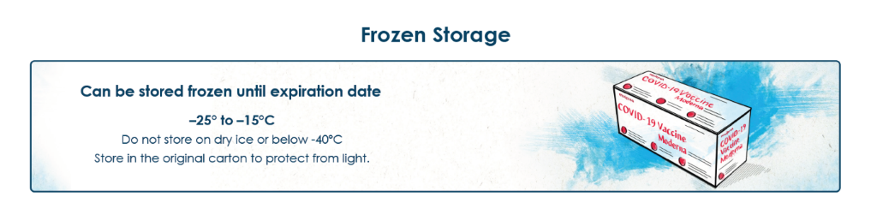







**Annex IV**

**Conclusions on the granting of the conditional marketing authorisation presented by the European Medicines Agency**

**Conclusions presented by the European Medicines Agency on:**

* **Conditional marketing authorisation**

The CHMP having considered the application is of the opinion that the risk-benefit balance is favourable to recommend the granting of the conditional marketing authorisation as further explained in the European Public Assessment Report.